**Application**

**A.**

**There is one value that is smaller than 0 but there is no value that is bigger than 100 in the recomputed dataset.**

**So we will set the negative value to 0.**

**By comparing the data, there are some erroneous values in the variable “SiriBFPerc”.**

**Thus, we employ the recomputed variable.**

**Check also variables “Weight”, “Height”, “AbdomenC” by plotting data:**

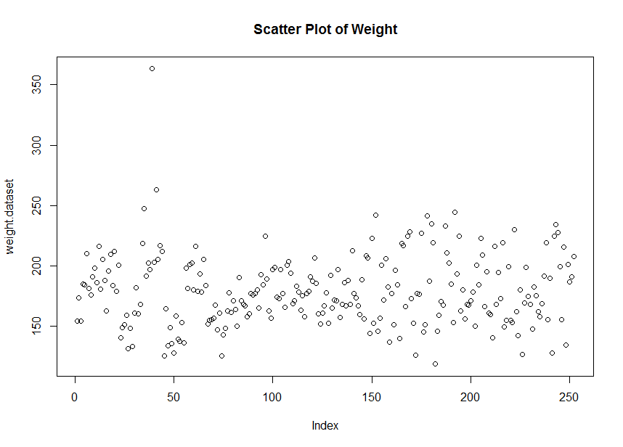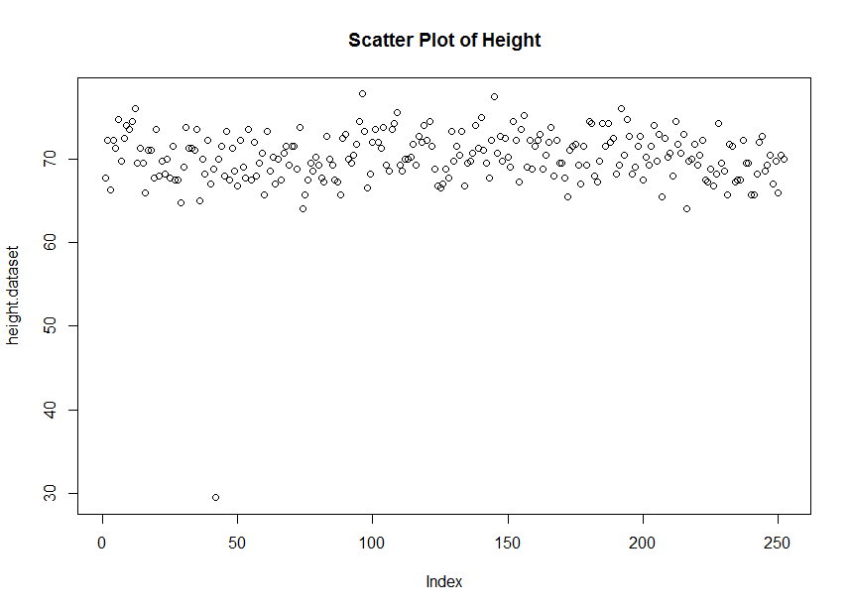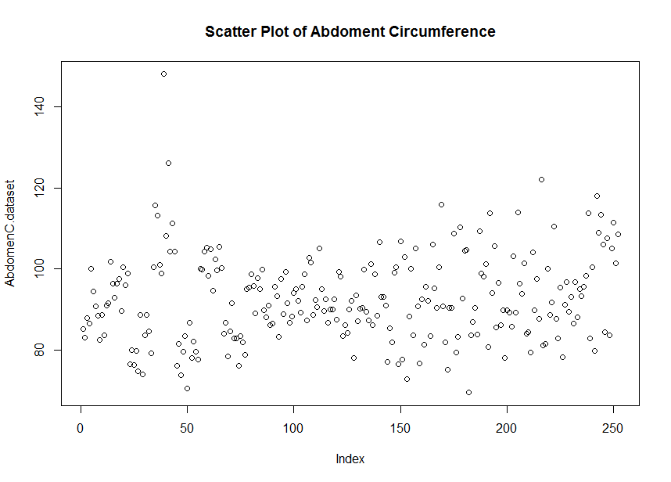

**By observing the scatter plots, we can see some obvious mistakes.**

**Thus, we want to find these mistakes and remove them by checking**

> bodyfat$Weight > 350

> bodyfat$AbdomenC > 140

> bodyfat$Height < 40

**I find out that 2 observations contains those mistakes, so we remove those observations.**

**Now, we should have a good dataset for further analysis.**

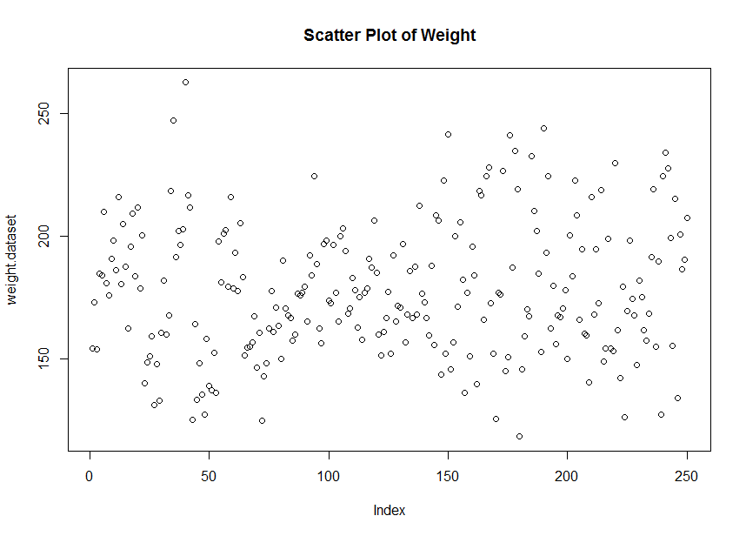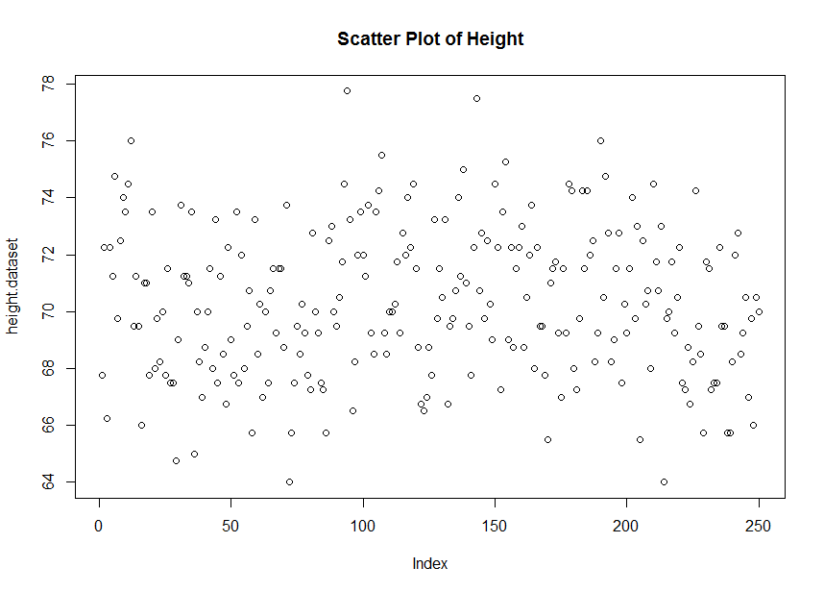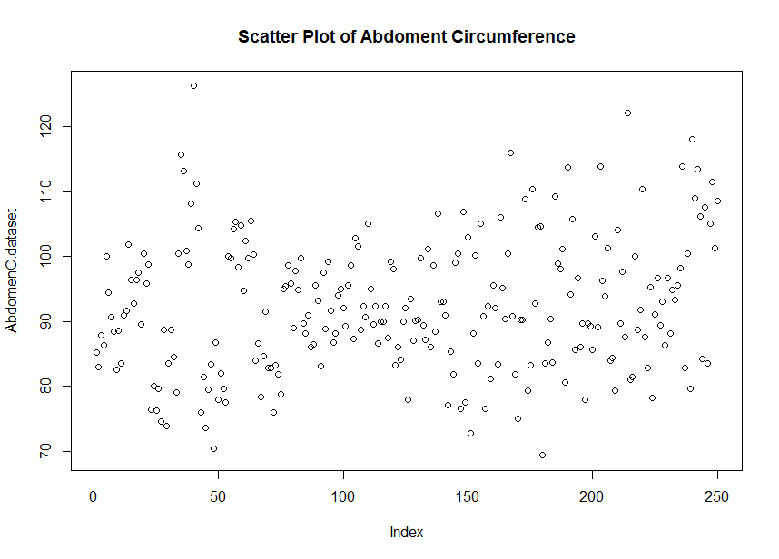

**B.**

**For body fat percentage:**

Min. 1st Qu. Median Mean 3rd Qu. Max.

0.00 12.40 19.20 18.99 25.18 47.50

**Standard deviation = 8.357805 IQR = 12.775**

**For weight:**

Min. 1st Qu. Median Mean 3rd Qu. Max.

118.5 158.5 176.1 178.1 196.8 262.8

**Standard deviation = 27.03549 IQR = 38.25**

**For height:**

Min. 1st Qu. Median Mean 3rd Qu. Max.

64.00 68.25 70.00 70.30 72.25 77.75

**Standard deviation = 2.616644 IQR = 4**

**For Abdomen Circumference:**

Min. 1st Qu. Median Mean 3rd Qu. Max.

69.40 84.53 90.90 92.29 99.17 126.20

**Standard deviation = 10.20744 IQR = 14.65**

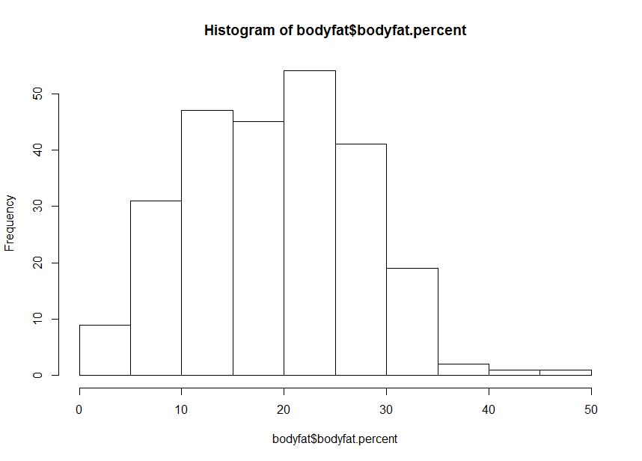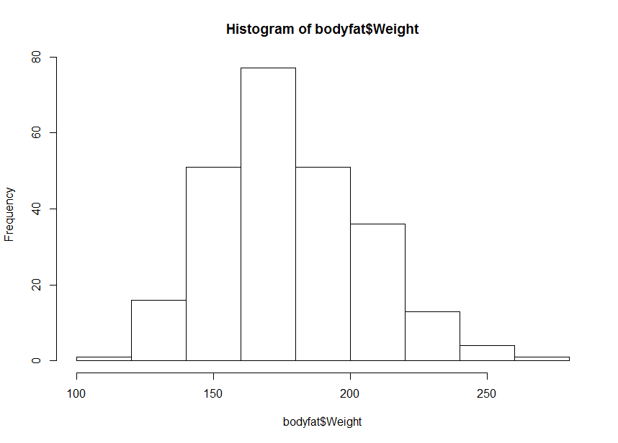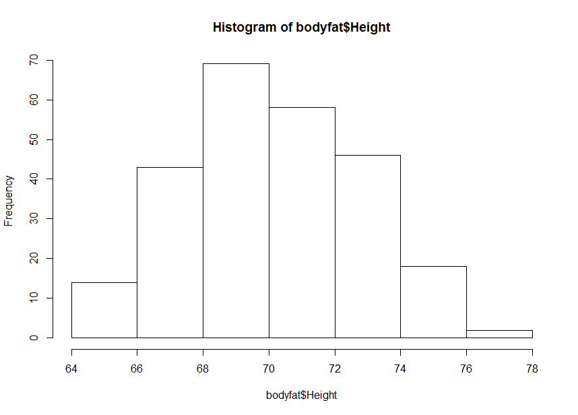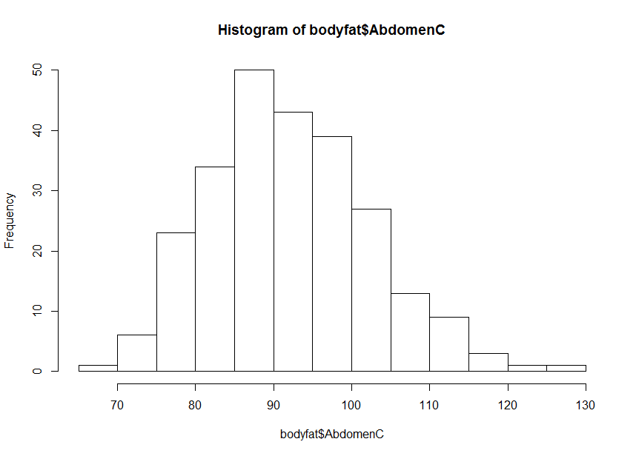

**All these distributions above appear to be symmetric and bell-shaped.**

**The variable Weight has the largest variability while the variable Height has the smallest variability based of the standard deviation of each variables. (ie, σweight > σAbdomen Circumference > σbodyfat percentage > σheight , same explanation for IQR)**

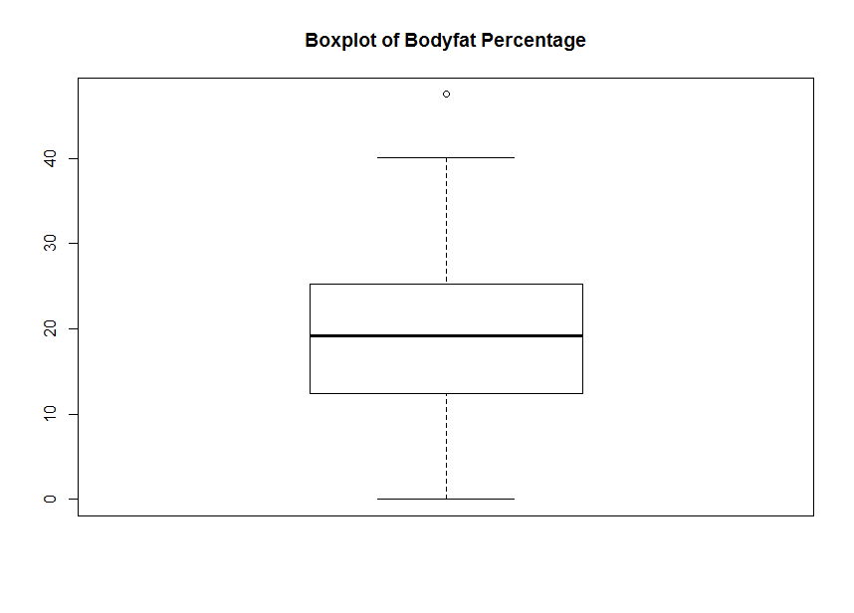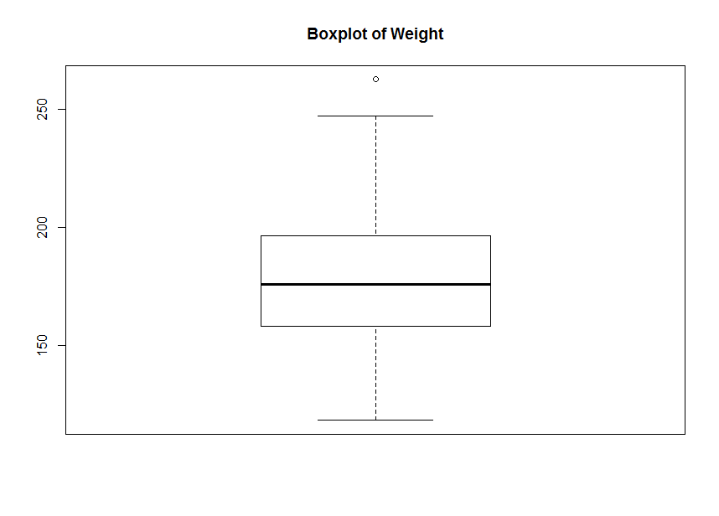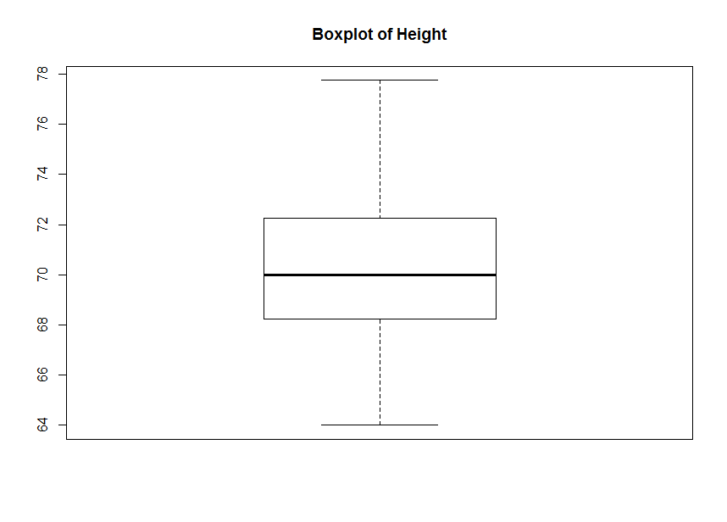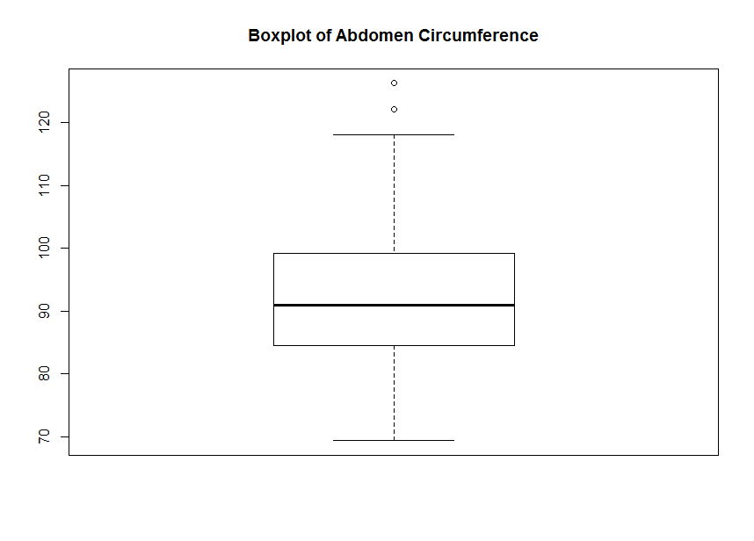

**Based on the boxplots, there are a few extreme values in distributions of Bodyfat Percentage, Weight, Abdomen Circumference.**

**Hypothesis test (using normal distribution) on body fat percentage:**

**H0 : average body fat percentage ≤20%**

**H1 : average body fat percentage > 20%**

**z-score = -1.91981 p-value = 0.972559**

**Thus, p-value = 0.972559** **> α, accept H0, which means the average body fat percentage does not exceed 20%.**

**Hypothesis test (using normal distribution) on weight:**

**H0 : average weight ≤ 180 pounds**

**H1 : average weight > 180 pounds**

**z-score = -1.121018 p-value = 0.8688599**

**Thus, p-value =0.8688599 > α, accept H0, which means the average weight does not exceed 180 pounds.**

**C.**

**∙ model employed: Y = β0+β1X+ϵ**

**Correlation of body fat percentage and weight = 0.5981014**

Residuals:

Min 1Q Median 3Q Max

-27.1676 -4.6126 0.0375 4.9613 20.9494

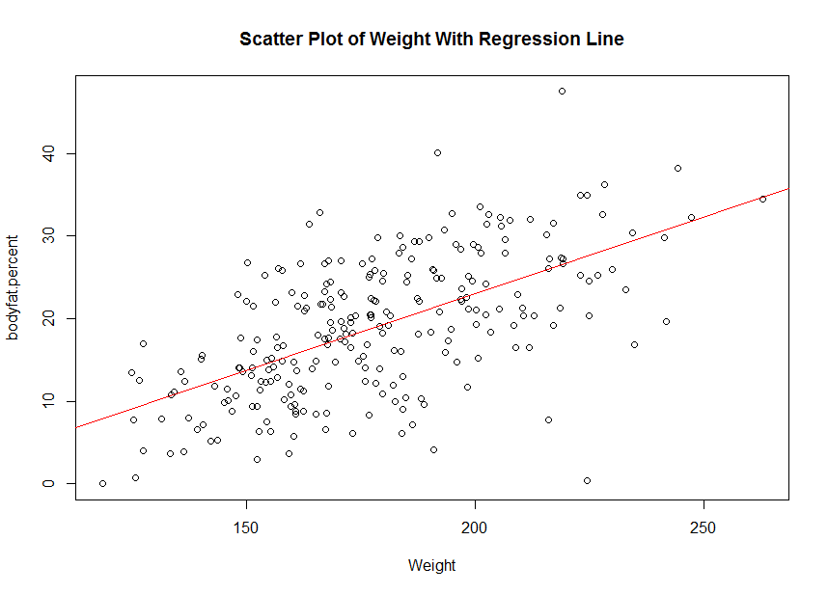Coefficients:

Estimate Std. Error t value Pr(>|t|)

(Intercept) -13.94208 2.83363 -4.92 1.58e-06 ***

Weight 0.18490 0.01573 11.75 < 2e-16 ***

---

Signif. codes: 0 ‘***’ 0.001 ‘**’ 0.01 ‘*’ 0.05 ‘.’ 0.1 ‘ ’ 1

Residual standard error: 6.712 on 248 degrees of freedom

Multiple R-squared: 0.3577, Adjusted R-squared: 0.3551

F-statistic: 138.1 on 1 and 248 DF, p-value: < 2.2e-16

**β̂0 = -13.94208 β̂1= 0.18490 σ2 = 45.04566 R2** **= 0.3577**

**Ŷ = -13.94208 + 0.18490X**

**Based on the slope of the regression line, Weight has positive relationship with body fat percentage.**

**The slope of the regression line represents the rate of change in body fat percentage as Weight changes, its estimated value = 0.18490 can be interpreted by saying that an increase of 1 pound in Weight causes an increase of 0.18490 percent in body fat percentage.**

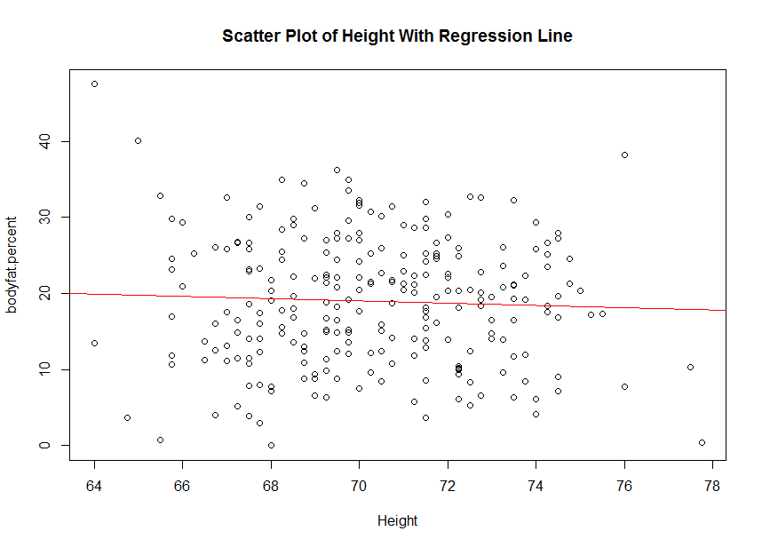

**∙ model employed: Y = β0+β1X+ϵ**

**Correlation of body fat percentage and height = -0.04854555**

Residuals:

Min 1Q Median 3Q Max

-19.3423 -6.5537 0.2821 6.2142 27.5375

Coefficients:

Estimate Std. Error t value Pr(>|t|)

(Intercept) 29.8863 14.2522 2.097 0.037 *

Height -0.1551 0.2026 -0.765 0.445

---

Signif. codes: 0 ‘***’ 0.001 ‘**’ 0.01 ‘*’ 0.05 ‘.’ 0.1 ‘ ’ 1

Residual standard error: 8.365 on 248 degrees of freedom

Multiple R-squared: 0.002357, Adjusted R-squared: -0.001666

F-statistic: 0.5858 on 1 and 248 DF, p-value: 0.4448

**β̂0 = 29.8863 β̂1= -0.1551 σ2=69.96925 R2 = 0.002357**

**Ŷ = 29.8863 + -0.1551X**

**Based on the slope of the regression line, Height has negative relationship with body fat percentage.**

**The slope of the regression line represents the rate of change in body fat percentage as Height changes, its estimated value = -0.1551 can be interpreted by saying that an increase of 1 cm in Height causes a decrease o f 0.1551 percent in body fat percentage.**

**∙ model employed: Y = β0+β1X+ϵ**

**Correlation of body fat percentage and Abdomen Circumference = 0.8110294**

Residuals:

Min 1Q Median 3Q Max

-23.1760 -3.5408 0.2143 3.1793 12.8435

Coefficients:

Estimate Std. Error t value Pr(>|t|)

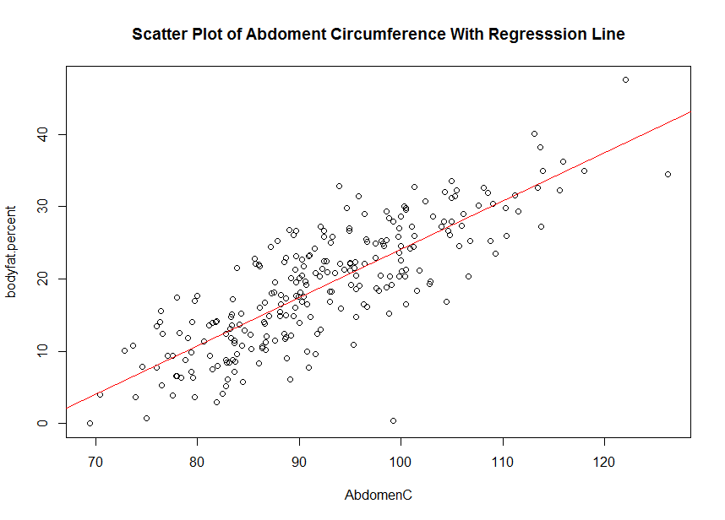(Intercept) -42.29941 2.82409 -14.98 <2e-16 ***

AbdomenC 0.66407 0.03042 21.83 <2e-16 ***

---

Signif. codes: 0 ‘***’ 0.001 ‘**’ 0.01 ‘*’ 0.05 ‘.’ 0.1 ‘ ’ 1

Residual standard error: 4.899 on 248 degrees of freedom

Multiple R-squared: 0.6578, Adjusted R-squared: 0.6564

F-statistic: 476.7 on 1 and 248 DF, p-value: < 2.2e-16

**β̂0 = -42.29941 β̂1= 0.66407 σ2=24.00225 R2 = 0.6578**

**Ŷ = -42.29941 + 0.66407X**

**Based on the slope of the regression line, Abdomen Circumference has positive relationship with body fat percentage.**

**The slope of the regression line represents the rate of change in body fat percentage as Abdomen Circumference changes, its estimated value = 0.66407 can be interpreted by saying that an increase of 1 cm in Abdomen Circumference causes an increase of 0.66407 percent in body fat percentage.**

**Since the regression between the body fat percentage and Abdomen Circumference has the largest**

**R2** **= 0.6584, Abdomen Circumference appears to be the best predictor for body fat percentage.**

**D.**

**∙ Correlation of body fat percentage and ratio = 0.6852458**

|  |
| --- |
| Residuals:  Min 1Q Median 3Q Max  -24.4946 -4.0063 0.0771 4.1833 14.2680  Coefficients:  Estimate Std. Error t value Pr(>|t|)  (Intercept) -22.746 2.843 -8.001 4.73e-14 ***  ratio 16.499 1.114 14.817 < 2e-16 ***  ---  Signif. codes: 0 ‘***’ 0.001 ‘**’ 0.01 ‘*’ 0.05 ‘.’ 0.1 ‘ ’ 1  Residual standard error: 6.099 on 248 degrees of freedom  Multiple R-squared: 0.4696, Adjusted R-squared: 0.4674  F-statistic: 219.5 on 1 and 248 DF, p-value: < 2.2e-16 |
|  |
|  |

**β̂0 = -22.746 β̂1= 16.499 σ2=37.20206 R2 = 0.4696**

**Ŷ = -22.746 + 16.499X**

**Based on the slope of the regression line, ratio has positive relationship with body fat percentage.**

**The slope of the regression line represents the rate of change in body fat percentage as ratio changes, its estimated value = 16.499 can be interpreted by saying that an increase of 1 unit in ratio causes an increase of 16.499 percent in body fat percentage.**

**Since the value of R2 of regression between ratio and body fat percentage is larger than that of regression between the body fat percentage and Height and that of regression between the body fat percentage and Weight, the ratio is a better predictor than weight and height.**

**E.**

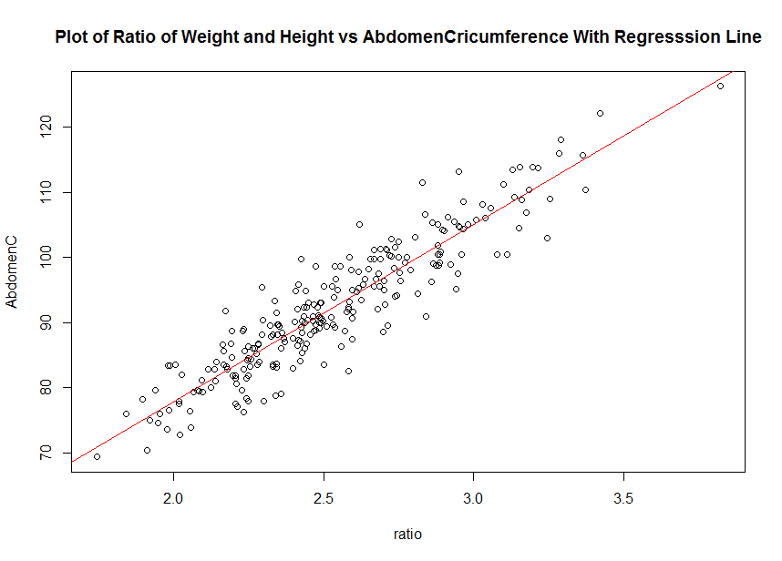**∙ Correlation of Abdomen Circumference and ratio = 0.9236815**

Residuals:

Min 1Q Median 3Q Max

-11.1934 -2.1244 0.0125 2.5932 11.0578

Coefficients:

Estimate Std. Error t value Pr(>|t|)

(Intercept) 23.5862 1.8265 12.91 <2e-16 ***

ratio 27.1620 0.7155 37.96 <2e-16 ***

---

Signif. codes: 0 ‘***’ 0.001 ‘**’ 0.01 ‘*’ 0.05 ‘.’ 0.1 ‘ ’ 1

Residual standard error: 3.919 on 248 degrees of freedom

Multiple R-squared: 0.8532, Adjusted R-squared: 0.8526

F-statistic: 1441 on 1 and 248 DF, p-value: < 2.2e-16

**β̂0 = 23.5862 β̂1= 27.1620 σ2=15.35835 R2 = 0.8532**

**Ŷ = 23.5862 + 27.1620X**

**Based on the slope of the regression line, ratio has positive relationship with Abdomen Circumference.**

**The slope of the regression line represents the rate of change in Abdomen Circumference as ratio changes, its estimated value = 27.1620 can be interpreted by saying that an increase of 1 unit in ratio causes an increase of 27.1620 cm in Abdomen Circumference.**

**Since the regression between the ratio and Abdomen Circumference has a large R2** **= 0.8532, this regression line fits the data pretty well and ratio appears to be a very good predictor for Abdomen Circumference.**

**Thus, with strong correlation between Abdomen Circumference and ratio (correlation = 0.9236815, which is close to 1) and the well-fitted regression line we just addressed above, we can conclude that change in weight/height ratio and Abdomen Circumference will have similar effect to body fat percentage. Thus, weight/height ratio and Abdomen Circumference seem to “capture” the same underlying information.**